Collaborative Paired Tasks

( the last two are involved with more than 2 students)

Work & Relaxation

Student A and B
A young man works very hard, and has only one free day a week. He wants to find an activity to help him relax. Here are some activities that could help him relax. Talk together about the different activities he could do and how relaxing they would be for him. Try to agree about the three most relaxing ones.
Start when you are ready.
Prompts fot the interlocutors:
- What do you do when you want to relax? (Why?)
- Do you prefer to relax with friends or alone? (Why?)
- Is it important to do exercise in your free time? (Why?/Why not?)
- Is it useful to learn new skills in your free time? (Why?/Why not?)
- Do you think people spend too much time working/studying these days? (Why?/Why not?)
- What could be the advantages and disadvantages of the activities drawn in the picture? (indoor/outdoor, winter/summer activities, noise, rain etc.,)
- What activities or sports do you usually do?
- What activities or hobbies would you like to take up?
- Have you ever tried Orintal techniques to relax yourself?

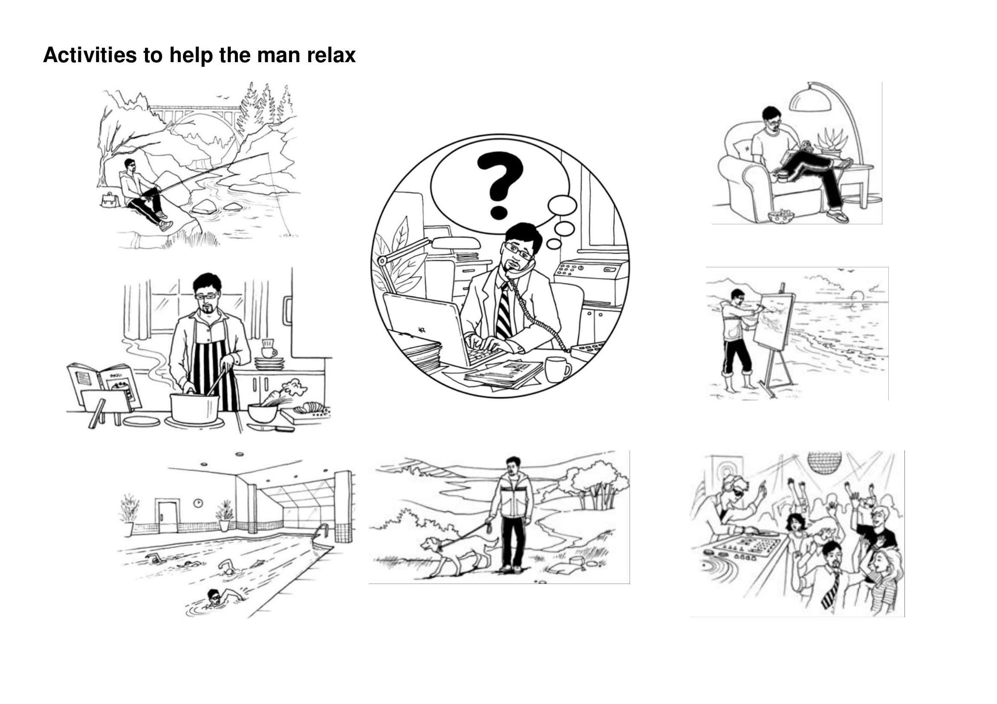
Clothes

Participants: Candidate and Examiner
These two pictures show a young couple of teenagers and a Scottish family portrait taken in occasion of a wedding. Describe what you see in the foreground and in the background, compare and contrast the two pictures. Include the following points:
1. Items of clothing
2. Clothes as expression of people's personality, mood, culure, lifestyle and social context

3. Clothes carrying messages, writings, famous quotes, new ideas and shapes

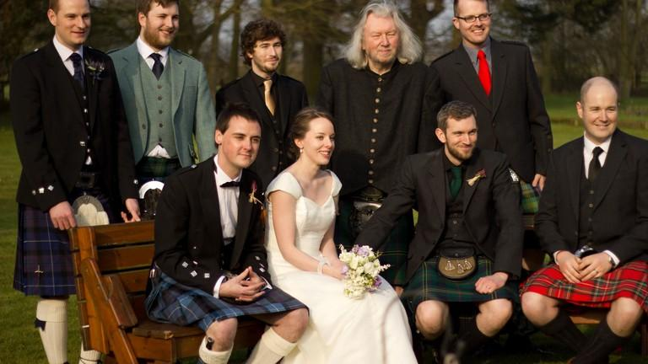

Shops & shopping

Participants: Candidate and Examiner
These photographs show two different shopping places: a street market and a shopping centre. Describe what you see in the foreground and in the background, compare and contrast the two pictures. Include the following points:
- Shops and shopping places
- Where you like to go shopping and what you like to buy
- Pros and cons of buying in big stores and at the market
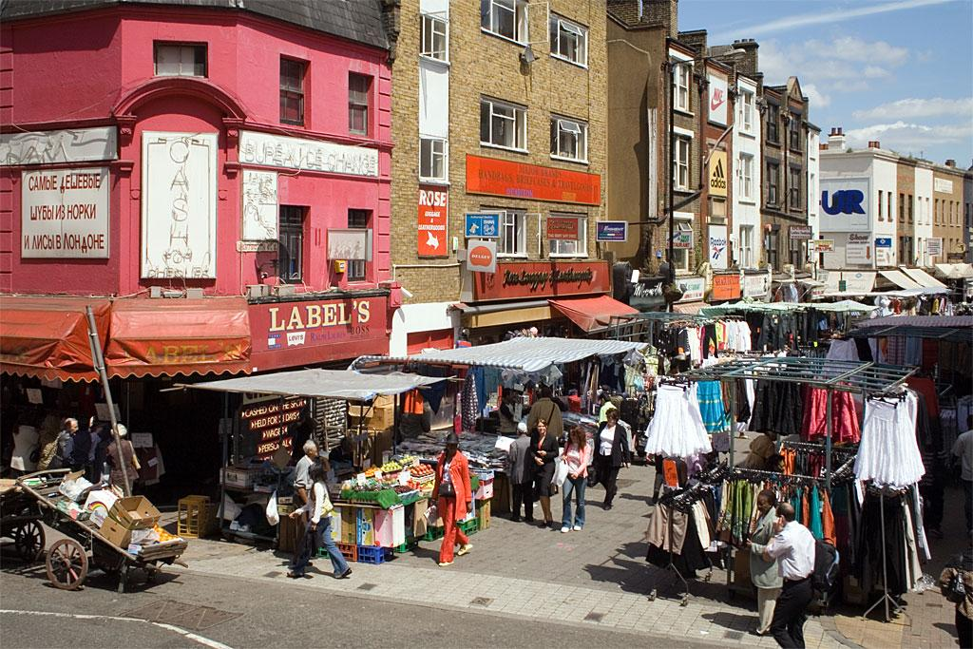

Choose a Presents

One of the students in your class is leaving to go and live abroad with his family. You would like to give him a present on the last day of school. Talk together about the sort of present you can give and then decide which will be the best.

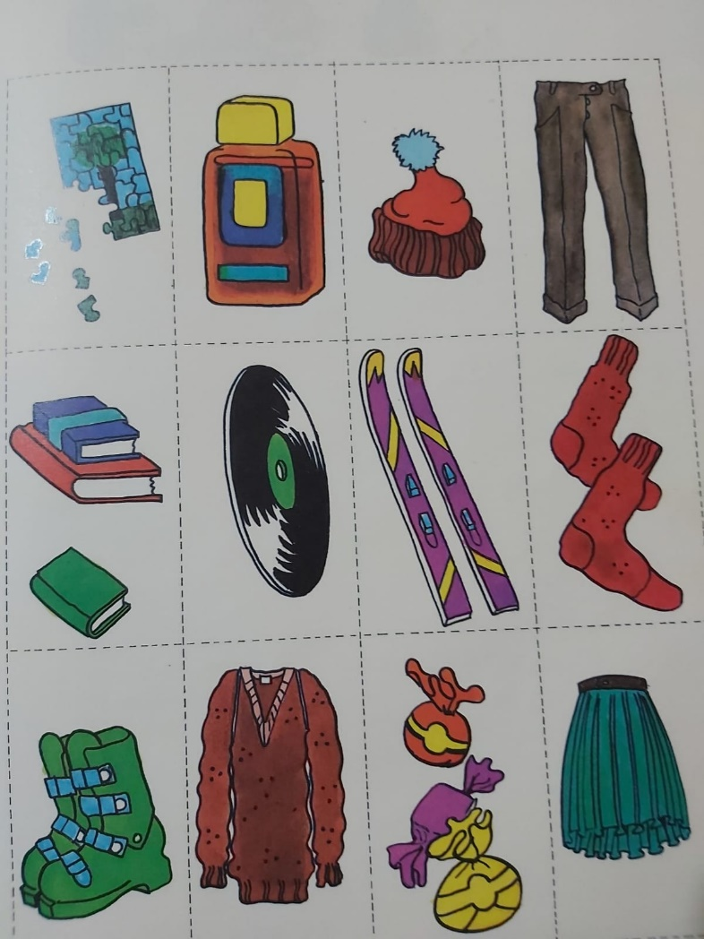
After the exam
Discuss how your class should celebrate the end of exams. Here are some ideas. Talk together about the different ideas and say which would be the most fun.
Use the following prompts:
- express your likes, dislikes and preferences
- give your opinion
- ask your friend’s opinion
- express agreement or disagreement

